Tuesday March 1st, 2001

Team project

Owners:

Jonathan Gravel

Boris Ionine

Bruno Colantonio

|  |  |
| --- | --- |
| 1. PacGame    1. Characters       1. PacMan       2. Ghost          1. Sam          2. Cam          3. Danny    2. PacWorld       1. PacDots       2. PowerPellets    3. PacGame 2. MouseGame    1. Characters       1. MouseHero       2. Mouse    2. MouseLand       1. MouseTrap       2. Exit    3. Game Play | 1. PipeGame    1. “Characters”       1. Plumber       2. Water    2. PipeMap       1. Pipe   3.2.1.1. Q pipe  3.2.1.2. I pipe  3.2.1.3. L pipe  3.2.1.4. T pipe  3.2.1.5. + pipe   * 1. PipeGame   4. Engine  4.1. Classes  4.1.1. Board  4.1.2. Tile  4.1.2.1. Avatar  4.1.2.1.1. Hero  4.1.2.1.2. NPC  4.1.2.2. Item  4.1.2.3. Wall  4.2. Game Play  4.2.1. Typical Movement |

**1. PacGame**

Based on the original ‘PacMan’, PacGame is a tile based and slow-motion type game which requires the character, PacMan, to collect all the PacDots on the grid, while avoiding or killing Ghosts.

**1.1. Characters**

The characters are classic. The Hero is PacMan, the Non Player Characters (NPCs) are Ghosts.

**1.1.1. PacMan**

PacMan is the hero of this game. He is controlled by the user and is followed by the ghosts. PacMan eats PacDots to gain points and to complete the game, and may also eat PowerPellets to become invulnerable and thus gain the ability to eat ghosts.

**1.1.2. Ghost**

PacGame has a population of Ghosts that are set out to catch and kill PacMan. In order to effectively do this, each Ghost has its own personality. Three ghosts exist in this version. Their names are Sam, Cam and Danny.

**1.1.2.1 Sam**

Sam is the sceptical Ghost, characterized by its orange color and (:S) face. It is always contemplating possible moves in order to cut off PacMan. This ghost tries to predict PacMan’s next position and moves towards this position. Sam will move away from PacMan when PacMan is inviulnerable.

**1.1.2.2 Cam**

Cam is the sad ghost, characterized by its blue color and ☹ face. It simply moves towards PacMan’s last position, regardless of of PacMan’s invulnerability. It is also pretty stupid.

**1.1.2.3 Danny**

Danny is the happy ghost, characterized by its (:D) face. It has no sense of purpose and randomly travels the grid at its leisure. There is no way to predict its next move.

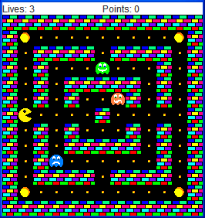**1.2. PacWorld**

PacWorld is composed of Walls and PacDots. The image to the right shows the starting positions of all the Ghosts and PacMan, as well as the location of the PacDots and PowerPellet.

**1.2.1. PacDot**

The PacDots feed PacMan points, and if all of them are collected, the game is won. **Each PacDot is worth 10 points**.

**1.2.2. PowerPellet**

The PowerPellet makes PacMan **invulnerable for the 10 turns**. While invulnerable, PacMan can eat Ghosts. The Ghosts that are eaten will not return for the duration of the level. After 10 turns, PacMan is vulnerable again and must avoid ghosts.

* 1. **Game Play**

The user is allowed to click in the *general* direction he would like to go. For example, if the user wishes to go right, he may click 6 squares to the right and 1 square up. The game will assume this is intended to be a move to the right and will move PacMan 1 square to the right if there are no obstructions. **In order to reduce the number of pop-ups in the game, the game will not alert you when you have made an incorrect move; the move will simply be ignored.**

**2. MouseGame**

MouseGame is a Tile based game and requires you to take your Hero Mouse called Cheesy and get through the maze to a finish point, while all the other evil mice try to catch you. Cheesy has some help, because he can drop a mouse trap whenever he wants to at his current location, provided he has mouse traps remaining in his inventory.

**2.1. Characters**

There are two different characters. The hero is a mouse called Cheesy, the enemies and Non Player Characters (NPCs) are mice called Red-Eyes.

**2.1.1. MouseHero**

Cheesy is the hero of this game and is trying to reach the finish line at the other end of the maze. But it is not simple because Cheesy is being chased by evil mice called Red-Eyes. In his favour he can drop a mouse trap at his position whenever he feels like it is useful; the mouse trap will eliminate the Red-Eyes. He is only aloud to drop one mouse trap at a time, but can go back and pick it up at anytime.

**2.1.2. Mouse**

The Red-Eye’s goal is to try to catch Cheesy, they do so by always going to the last position Cheesy has been. It seems pretty easy, but when you are cornered you have no way out.

**2.2. MouseLand**

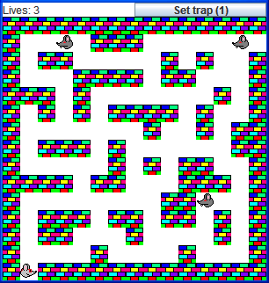MouseLand is composed of Walls and blank Tiles. The image to the right shows the starting positions of all the Mice and MouseHero. The exit is seen at the top right, where the hole in the walls is.

**2.2.1. Exit**

The Exit point as you can see is on the top right of the board where there is a space between the walls; once cheesy reaches that spot you win.

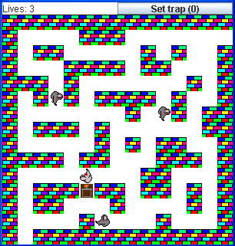

**2.2.2. Mouse Trap**

The mouse trap is show here by the little brown mouse trap. Cheesy only gets one mouse trap but can go pick it up at anytime. The mouse trap stays at the current position until Cheesy picks it up and places it to another spot. Once a Red-Eye is killed by the mouse trap, the image will change to a bloody mouse trap, that means it has already been used and the Red-Eyes cannot die unless reset.

**2.3. Game Play**

When the game has started all you do is left-click where you want Cheesy to go next, but he can only move one spot at a time. If you are clicking in a straight line but five spaces away it will take him five turns to get there. You want Cheesy to reach the empty space in the walls on the top right of the map. If you click the “Set trap (1)” button you will set a trap. If it says “Set trap (0)”, that means you already set your trap. If you want to replace it you have must first pick it up by walking over it. Once you have walked over the trap (used or unused) you will notice your trap count will be set back to one. If the trap is used and a Red-Eye walks over it again he will not die, meaning a trap is set when placed, but deactivated when a mouse steps on it (like a real mouse trap). You have three lives to reach the exit point. If you get caught everything is set back to the original position, except the mouse trap is still at the position you left it and you have one less life. Once you reach the end, the game will end asking you to play again or quit.

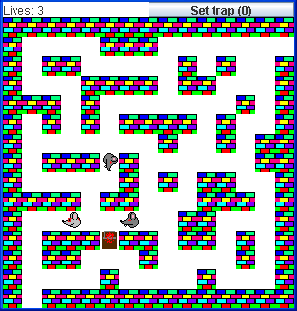

**3. PipeGame**

The game pipes is a tile based game, and the point of the game is to arrange a series of pipes such that the water does not overflow before reaching the end pipe. The type of pipe is chosen randomly for a new and exciting game every time!

**3.1. “Characters”**

There are two characters. The hero is the Plumber, the enemies and Non Player Characters (NPCs) is the water.

**3.1.1. Plumber**

Every turn the plumber gets a random type of pipe and he has to choose what tile to go on next for him “drop” the next pipe. If the plumber does not connect all the pipes together the water will overflow, causing the game to be lost.

**3.1.2. Water**

The water is the enemy in the game, it continues and splits to follow all open sides of the pipe (ex: the “+” pipe allows water to go up, down, left, right). Your first five turns the water does not move, then every action the water will leak to the tile(s) that the water can go.

**3.2. PipeMap**

PipeMap is initially composed of the initial start of where the water is and a plumber. In this textual representation, ‘**P’ symbolizes the plumber** and **the blank tiles are empty space** where you can place the next pipe.The ‘**Q’** shown here is -the starting position of the Water. The water is shown by a **‘w’**. The image shown here is the starting position of the PipeGame.

**3.2.1. Pipe**

Pipes are given to you randomly; right now you cannot see what the next pipe is going to be, but for the next milestone, it will be possible to see the next pipe coming (think of Tetris as an example). There are five different pipes.

**3.2.1.1. Q pipe (incoming = 1, outgoing = 0)**

The “Q” pipe can take water in from one side but then has a dead end.

**3.2.1.2. I pipe (incoming = 1, outgoing = 1)**

The “I” pipe can get incoming water in from one side and the water will come out on the opposite side it came from.

**3.2.1.3. L pipe (incoming = 1, outgoing = 1)**

The “L” pipe can get incoming water from one side and the water will leak out on either side but NOT both, depending where the water came in.

**3.2.1.4. T pipe (incoming = 1, outgoing = 2)**

The “T” pipe can get water coming in from one side and have two exit points, the exit points are on both sides of where the water came in.

**3.2.1.5. + pipe (incoming = 1, outgoing = 3):** -The “+” pipe can get water coming in from one side and the other three sides the water can exit.

**3.3. PipeGame**

Currently, only the “I” pipe is used. Since we don’t have any images, it is very difficult to show what the different pipes are. When you rotate the pipes you do not know how the pipe is rotated (what sides are open at start), for example the “I” pipe can let the water flow from up to down or left to right.

Initially the “I” pipe is set horizontally, but the plumber can rotate it after he has set it. To do so, the plumber just has to go on the tile the pipe is on and it will rotate by itself. The problem here is that we cannot rotate the character “I” so it seems that the pipe was not rotated.

In this game you control the plumber (“p”) by declaring the position you want to move to. “p” will have changed places after setting the position you desire, and you will notice that the tile “p” used to be on now holds an “I”. Keep in mind that “I” pipe is going from left to right so if you want it to be vertical, you have to move back to that tile to rotate it. You have 5 turns to play before the water starts to move, you will see pipes fill up as the water moves (“w” beside the pipe indicates water is inside).

To win the game you want the water to reach the open wall (tile 6, 1) and the water starts at tile (2, 1), So all you have to do is a straight line down, keep in mind you have to rotated every “I” pipe.

To test this, insurt:

(3,1)(4,1)(3,1)(5,1)(4,1)(6,1)(5,1)(6,1) then place the plumber at any blank area.

**4. Engine**

The engine describes the generic functionalities that all games may choose to use or overwrite. It contains basic classes and methods that match typical behaviour in a tile based game.

**4.1. Classes**

The classes provided by the engine are Board, Tile, Avatar, Hero, NPC, Item and Wall.

**4.1.1. Board**

The board is where the game is played. There is a method provided that carries out a typical turn, given a Position. This method moves the Avatar based on the given position, than moves the NPC’s based on the Avatar’s position. Each game board is responsible for setting up the layout of the [item] Map prior to initializing a game.

**4.1.2. Tile**

Everything that is placed on the board is a Tile. The Tile is the superclass for any all other classes that are present on the board. The Tile class also represents an empty space on the map.

**4.1.2.1. Avatar**

Avatar is everything that can move on the board. It is the superclass to Hero and NPC and contains methods are used to react to items on the board or how they move.

**4.1.2.1.1. Hero**

Hero is the user controlled Avatar that has a specific goal to accomplish.

**4.1.2.1.2. NPC**

NPC is the AI based Avatar that generally gets in the way of the Hero’s goal

**4.1.2.2. Item**

Items are initially placed on the map, and removed as they are picked up. They generally have consequences such as increasing points, killing Avatars, or other creative purposes.

**4.1.2.3. Wall**

A wall should not be accessed by Avatars unless specifications declare otherwise. They serve to create a maze like feel in a game.

**4.2. Game Play**

All tile based games using this engine use click-move functionality. For the most part, this involves clicking anywhere on the map, resulting in the movement of Avatars based on the position of the clicked tile.

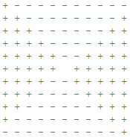 **4.2.1. Typical Movement**

In the majority of games, the movement of the avatar is one space to the North, South, East or West direction. If the user clicks on a tile that does not lie within this one space limit, the engine will compute what is assumed to be the desired direction. The grid on the right illustrates how the engine determines the direction. The Hero lies in the middle of the grid, and upon clicking inside the + region, it will move either left or right, if there is no Wall where it is to go. The – region will move the Hero either upwards or downwards. This allows the user to spend less time choosing which tile to click.